GYROSCOPE KALMAN FILTER



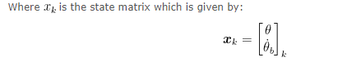





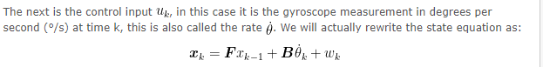



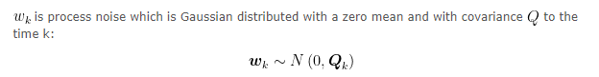

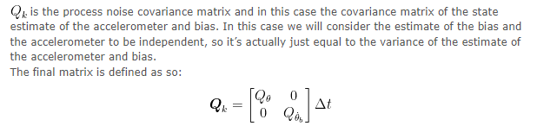

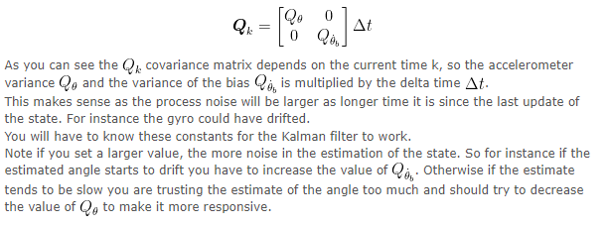

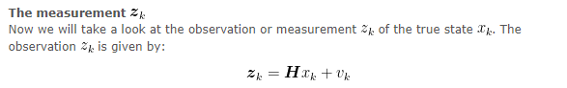





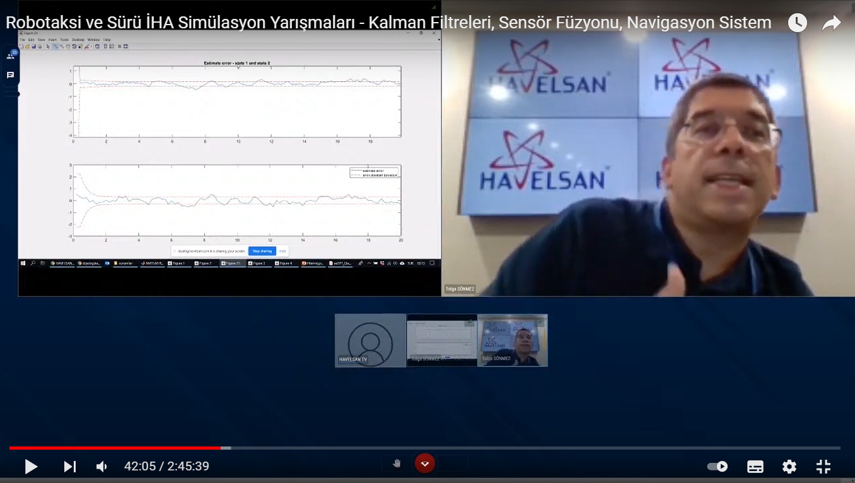

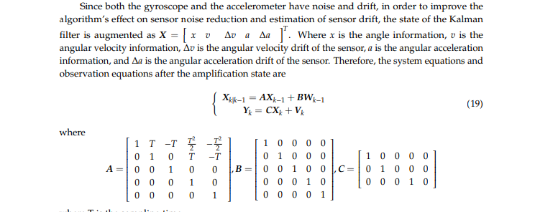

clc

clear

clear all

clf

real_value1=load("x.txt");

real_value2=load("y.txt");

real_value3=load("z.txt");

real_value=[real_value1 real_value2 real_value3];

filtered_valx=zeros(length(real_value),1);

filtered_valy=zeros(length(real_value),1);

filtered_valz=zeros(length(real_value),1);

for i=1:length(real_value)

z=real_value(i,1:3);

[y,klm_gain] = muhammet(z);

filtered_valx(i)=y(1,1);

filtered_valy(i)=y(1,2);

filtered_valz(i)=y(1,3);

gain(i)=klm_gain(1);

end

plot(real_value1,'r');

hold on

plot(filtered_valx,'b');

legend('real value(red)','filtered value(blue)')

title('for x')

figure

plot(real_value2,'r');

hold on

plot(filtered_valy,'b');

legend('real value(red)','filtered value(blue)')

title('for y')

figure

plot(real_value3,'r');

hold on

plot(filtered_valz,'b');

legend('real value(red)','filtered value(blue)')

title('for z')

figure

plot(gain);

title('kalman gain');

clc

clear

clear all

real_value=load("x.txt");

filtered_val=zeros(length(real_value),1);

for i=1:length(real_value)

z=real_value(i);

[y,klm_gain] = muhammet(z);

filtered_val(i)=y(1);

gain(i)=klm_gain(1);

end

plot(real_value,'r');

hold on

plot(filtered_val,'b');

legend('real value(red)','filtered value(blue)')

figure

plot(gain)